Unit 2 – Building Functions from Other Functions
Overview

Topics
2 – 1. Piecewise functions
2 – 2. Point slope form of the line
2 – 3. Plot/explain parametric paths
2 – 4. Convert parametric equations to cartesian form
2 – 5. Parametric equations for linear motion
2 – 6. Creating parameterizations (cartesian parametric)
2 – 7. Parametric equations for circular motion

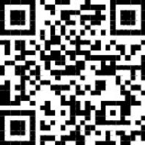
Desmos: How to define piecewise functions
https://tinyurl.com/fhs-desmos-piecewise
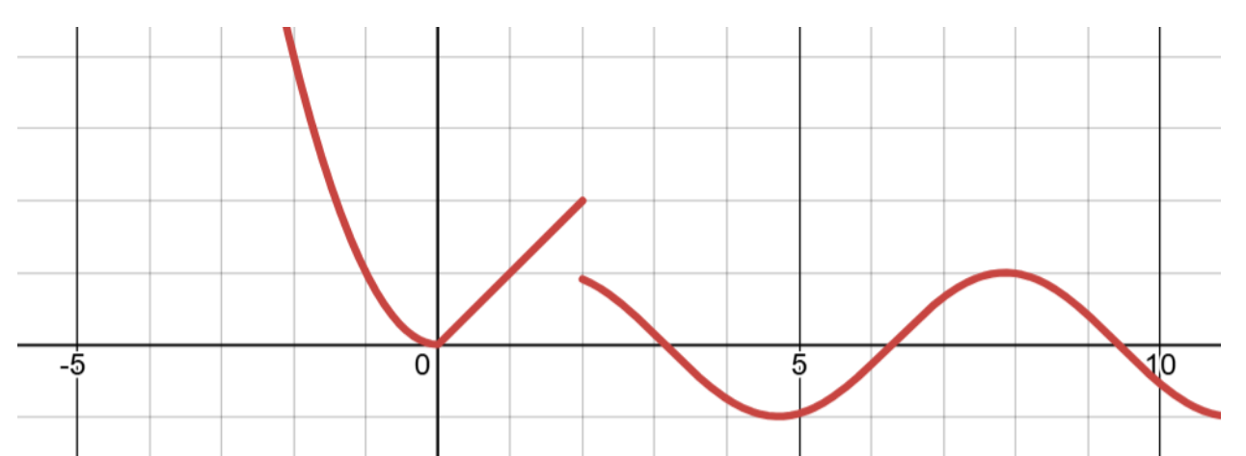
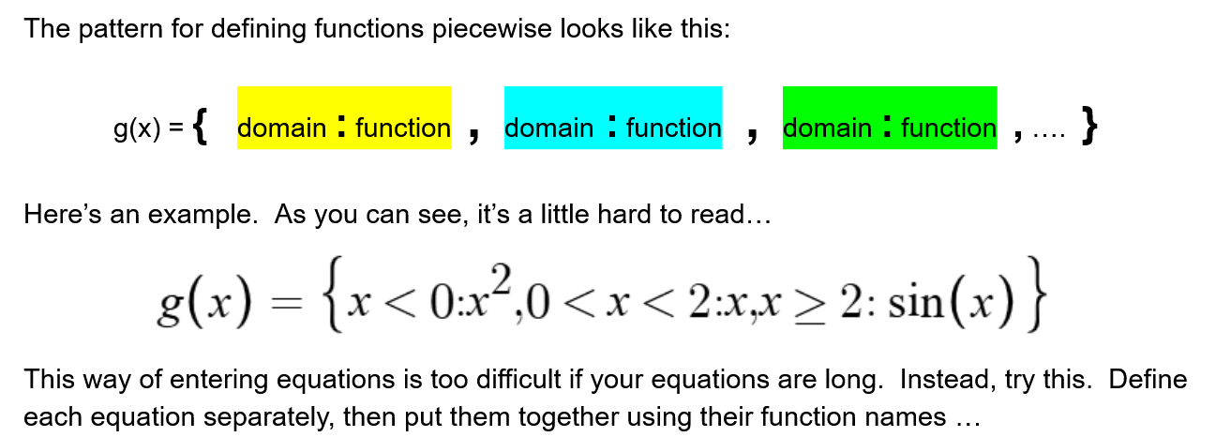

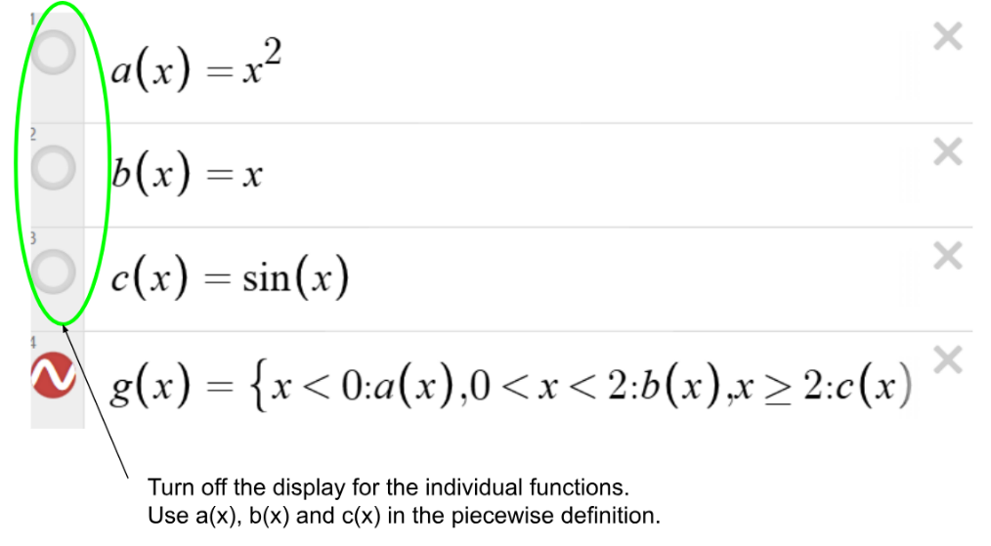

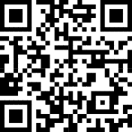
Desmos: Parametric equations
https://tinyurl.com/fhs-desmos-parametric
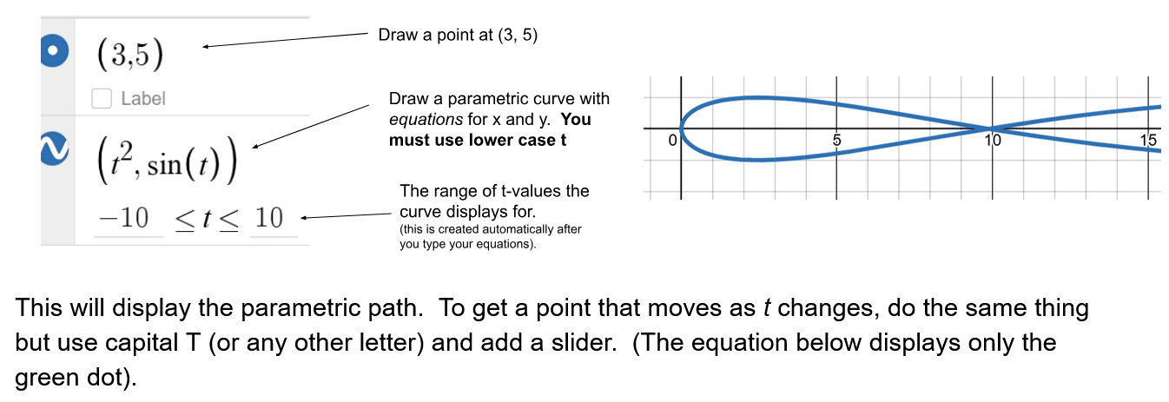

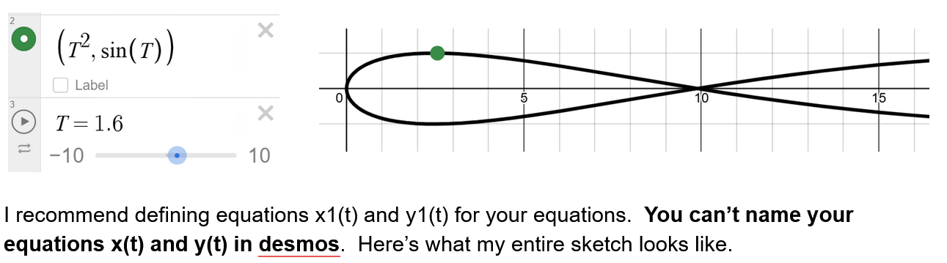
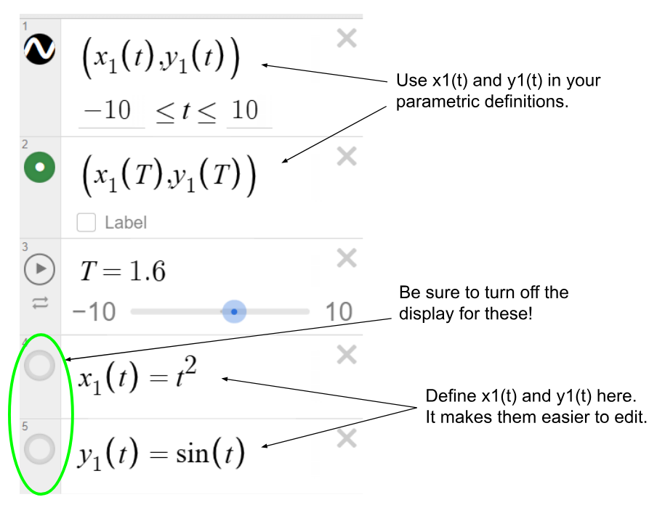
Desmos: Parametric equations defined piecewise
This is just the previous two ideas put together.
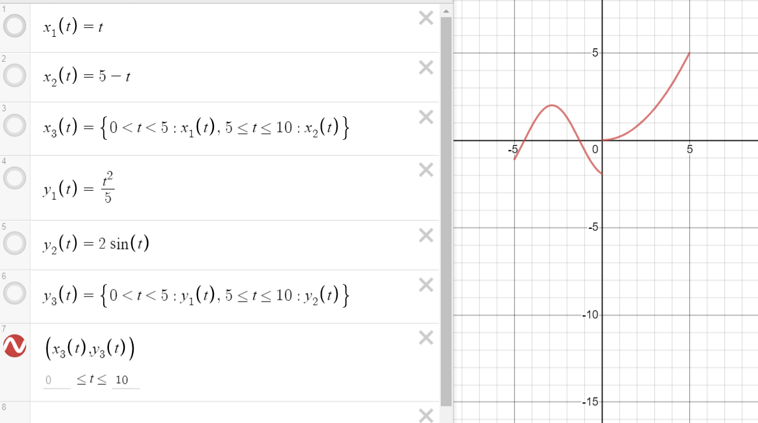
The first 3 lines are a piecewise defined function for x(t). One piece for times from 0 to 5, and another for times from 5 to 10.
The next 3 lines do the same for y(t).
The red highlighted line makes the parametric equation from the two piecewise functions.

